**Q. 1 Using console.log() print out the following statement: The quote 'There is no exercise better for the heart than reaching down and lifting people up.' by John Holmes teaches us to help one another. Using console.log() print out the following quote by Mother Teresa:**

**ANS -**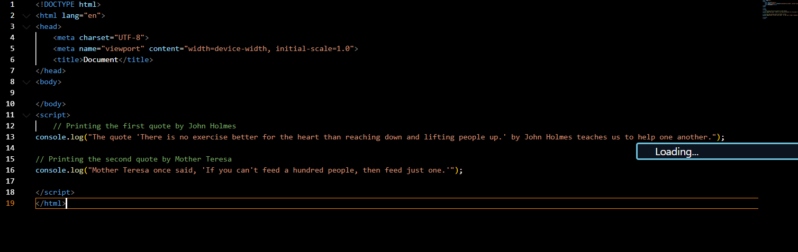

**Out put :**

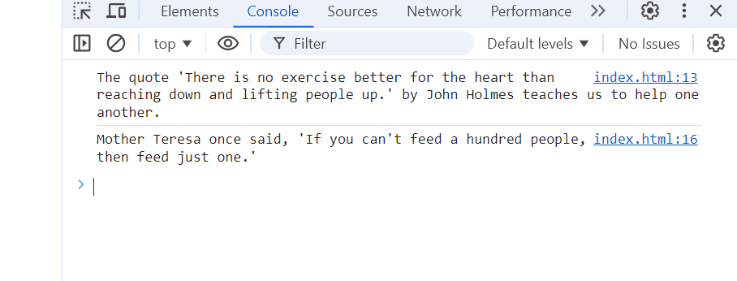

**Q. 2 Check if typeof '10' is exactly equal to 10. If not make it exactly equal?**

**Ans -** 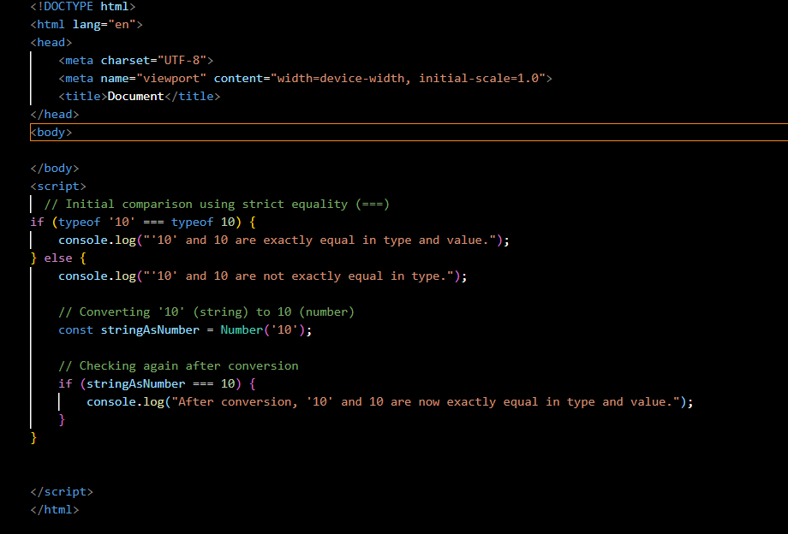

**Output -** 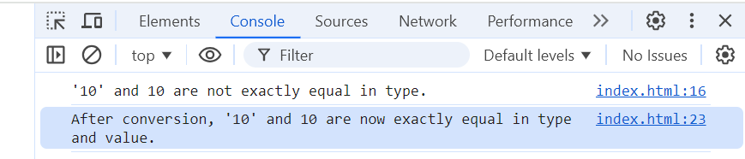

**Q. 3 Write a JavaScript Program to find the area of a triangle?**

**Ans -** 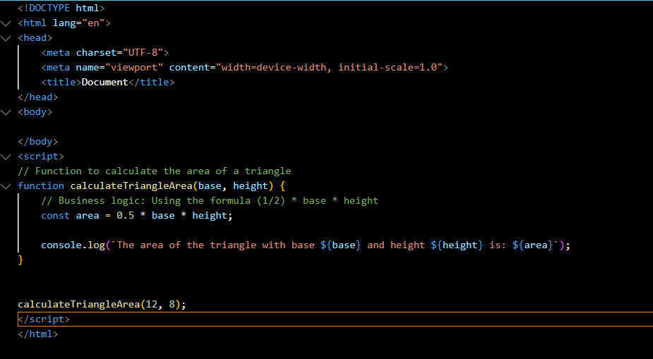

**Output ;**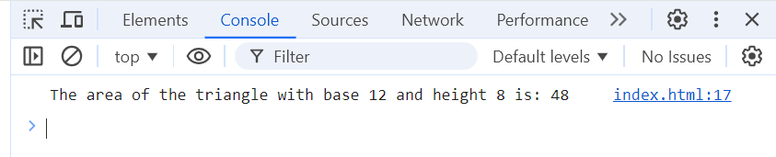

**Q. 4 Write a JavaScript program to calculate days left until next Christmas?**

**Ans –**

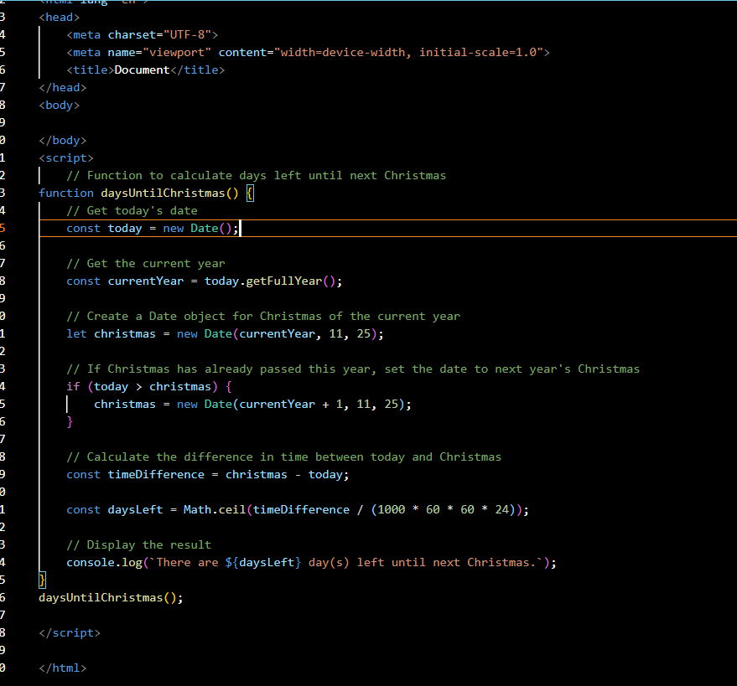

**Output**

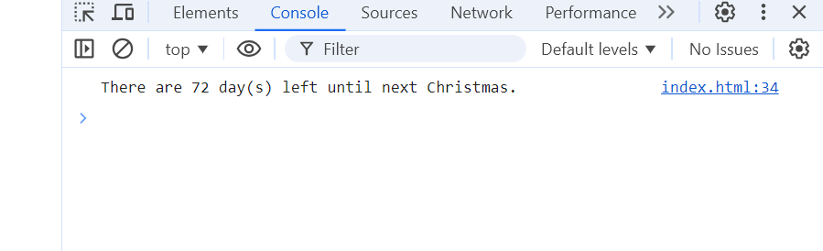

**Q. 5 What is Condition Statement?**

A condition statement (also known as a conditional statement) in programming is a feature that allows code execution based on whether a specific condition is true or false. It enables decision-making in programs by executing certain blocks of code depending on the outcome of a condition.

In JavaScript, common conditional statements are:

1. if statement:
   * Executes a block of code if a specified condition is true.

javascript

Copy code

let age = 18;

if (age >= 18) {

console.log("You are eligible to vote.");

}

1. if...else statement:
   * Executes one block of code if the condition is true, and another block of code if the condition is false.

javascript

Copy code

let age = 16;

if (age >= 18) {

console.log("You are eligible to vote.");

} else {

console.log("You are not eligible to vote yet.");

}

1. else if statement:
   * Allows multiple conditions to be checked. If the first condition is false, the next condition is evaluated, and so on.

javascript

Copy code

let score = 75;

if (score >= 90) {

console.log("You got an A.");

} else if (score >= 80) {

console.log("You got a B.");

} else if (score >= 70) {

console.log("You got a C.");

} else {

console.log("You need to improve.");

}

1. switch statement:
   * Compares a value against multiple possible outcomes (called "cases") and executes the corresponding block of code.

javascript

Copy code

let day = 3;

switch(day) {

case 1:

console.log("Sunday");

break;

case 2:

console.log("Monday");

break;

case 3:

console.log("Tuesday");

break;

default:

console.log("Invalid day");

}

**Q. 6 Find circumference of Rectangle formula : C = 4 * a ?**

**Ans –**

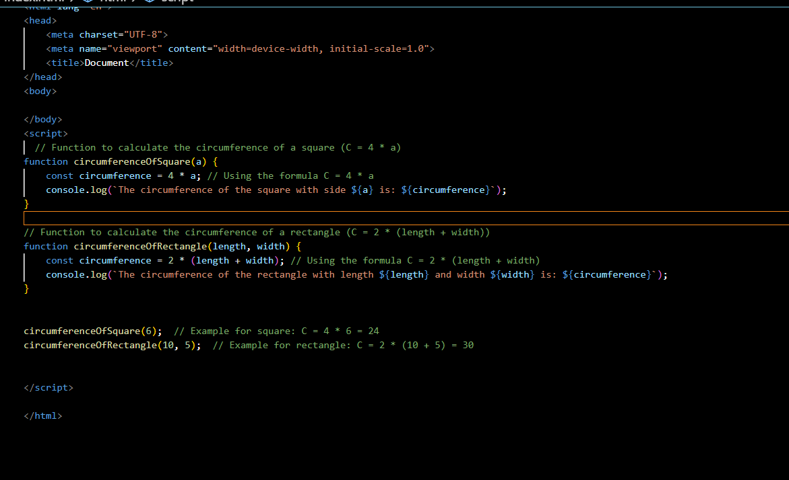

**Output –**

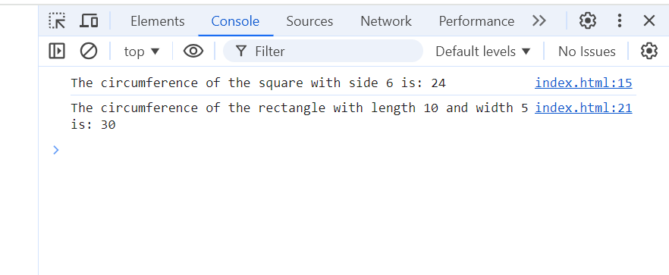

**Q. 7 WAP to convert years into days and days into years?**

**Ans -**

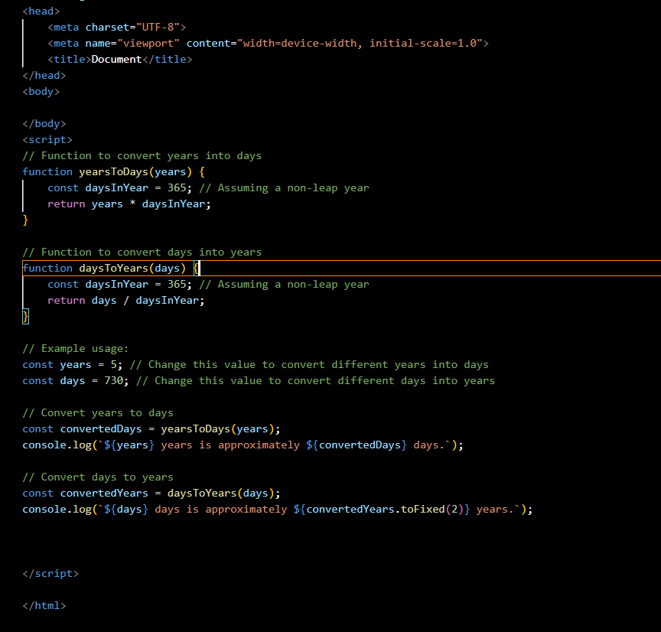

**Output –**

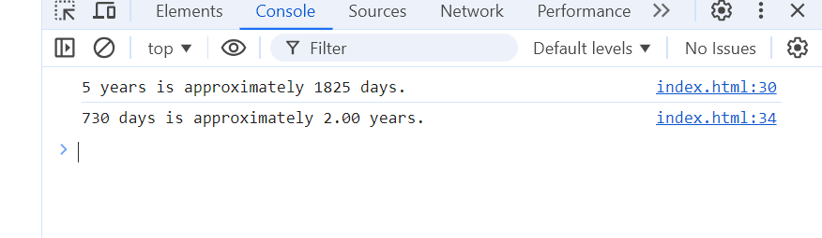

**Q. 8 Convert temperature Fahrenheit to Celsius? (Conditional logic Question)**

**Ans –**

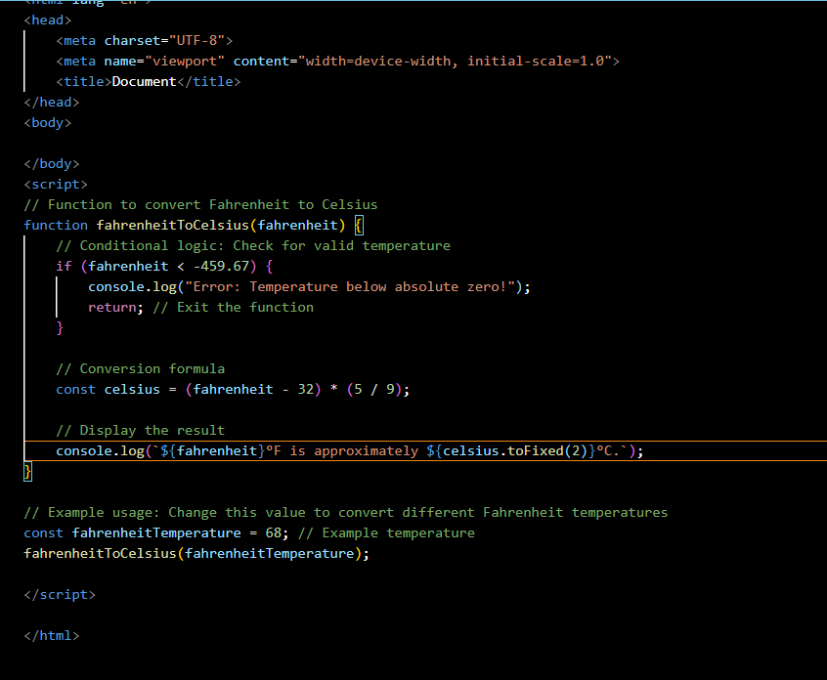

**Output -** 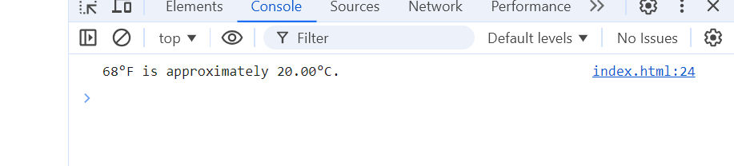

**Q. 9 Write a JavaScript exercise to get the extension of a filename.?**

**Ans -** 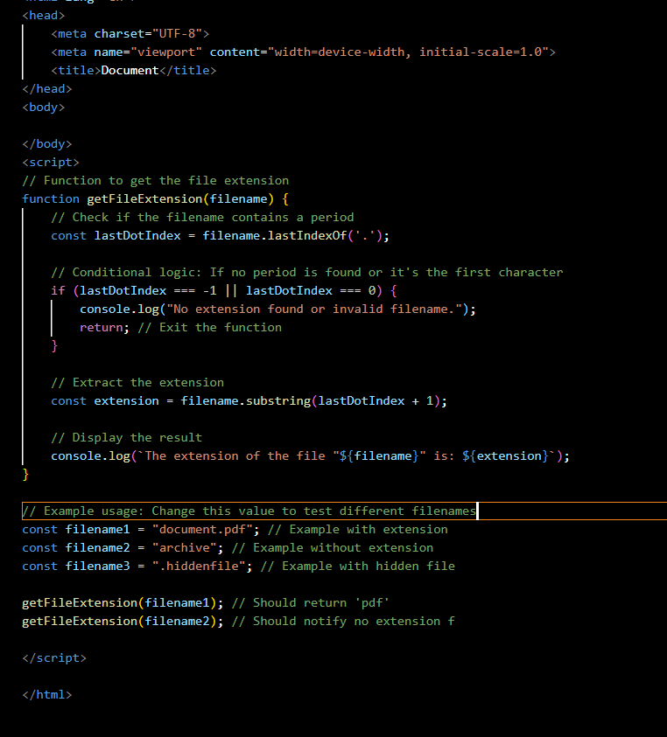

**Output**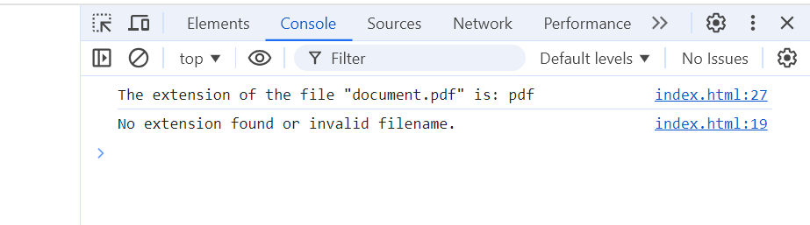

**Q. 10 What is the result of the expression (5 > 3 && 2 < 4)?**

**Ans -**

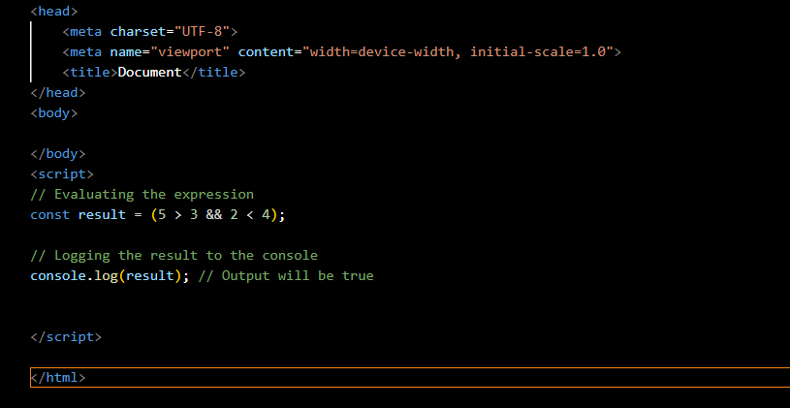

**Output -** 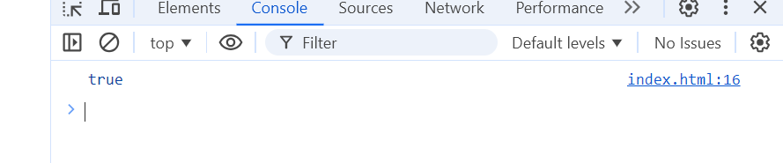

**Q.11 What is the result of the expression (true && 1 && "hello")?**

**Ans -** 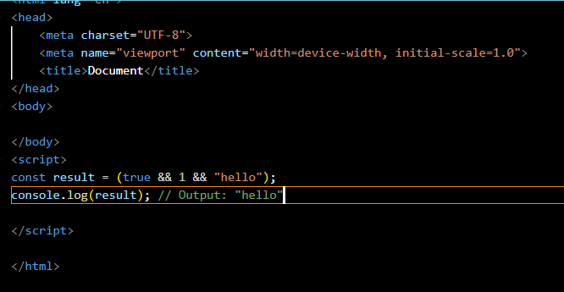

**Output –**

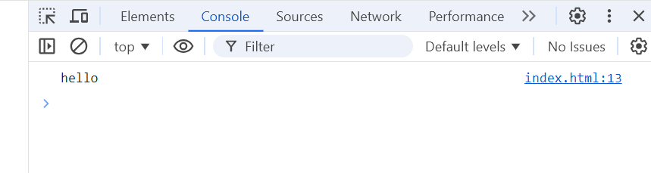

**Q. 12 What is the result of the expression true && false || false && true?**

**Ans -**

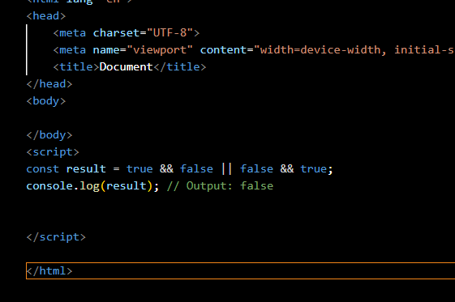

**Output -**

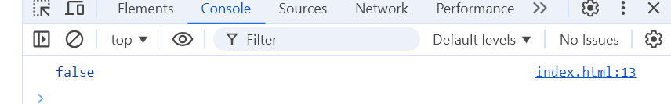

**Q. 13 Check Number Is Positive or Negative in JavaScript?**

**Ans -**

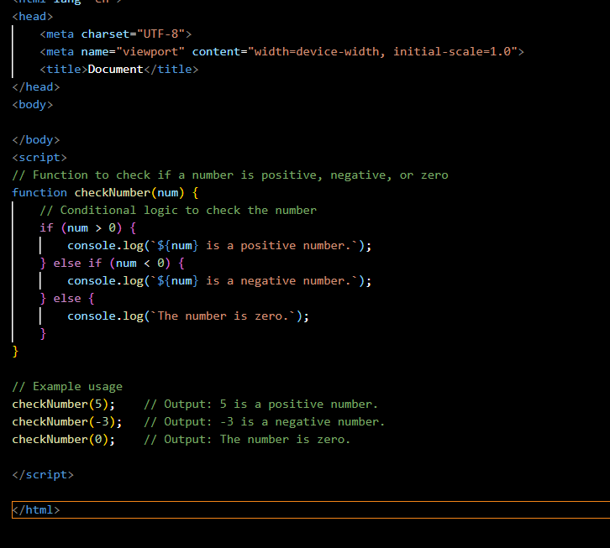

**Output -** 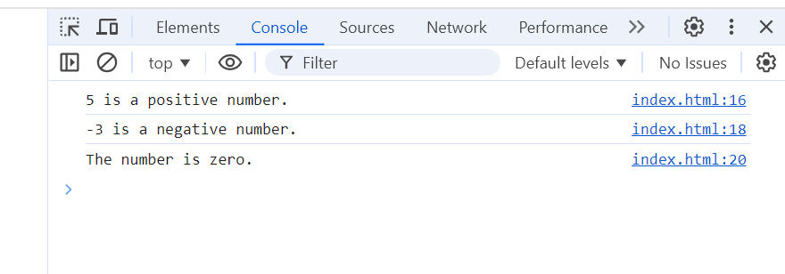

**Q. 14 Find the Character Is Vowel or Not ?**

**Ans -**

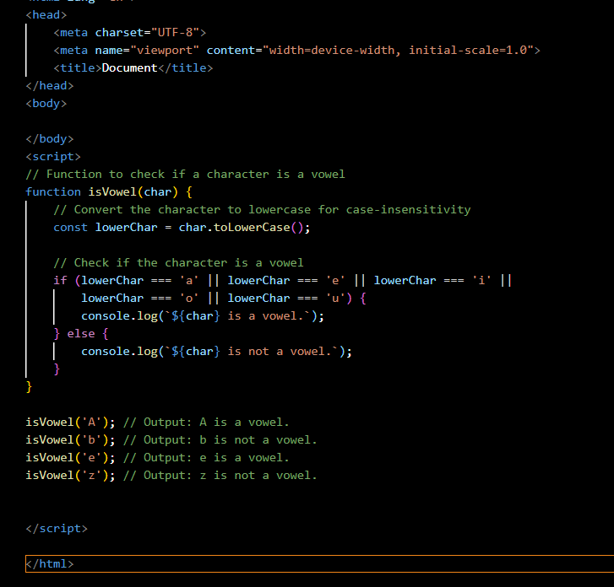

**Output -** 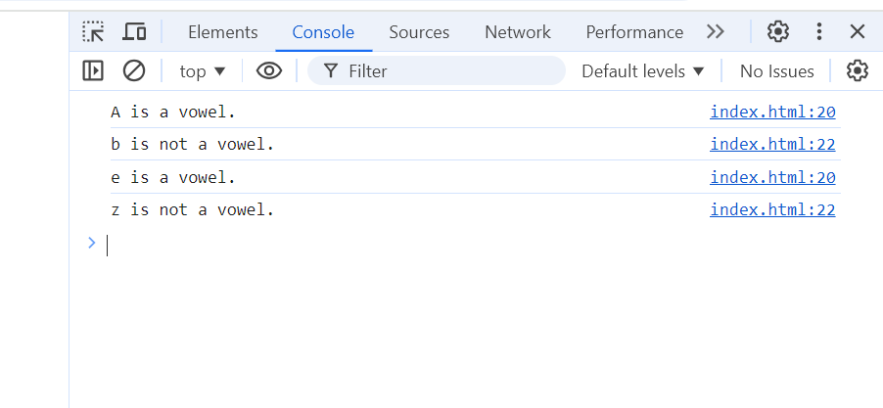

**Q. 15 Write to check whether a number is negative, positive or zero?**

**Ans -**

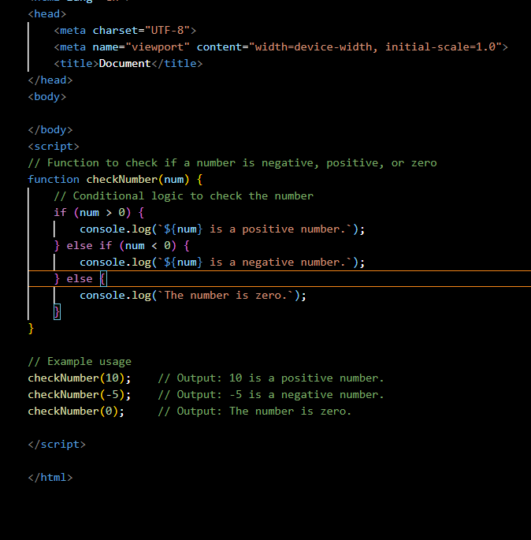

**Output**

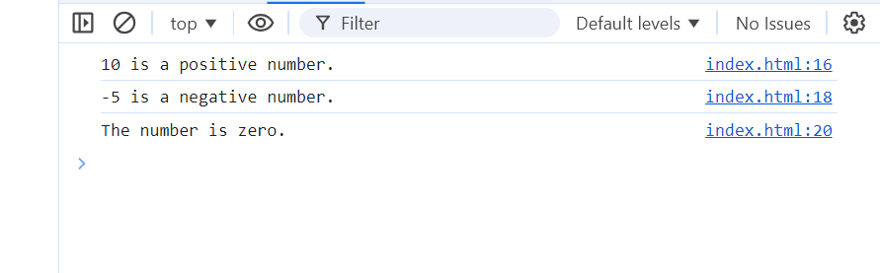

**Q. 16 Write to find number is even or odd using ternary operator in JS?**

**Ans -**

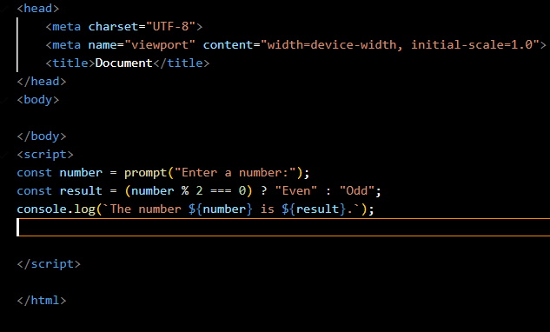**output -**

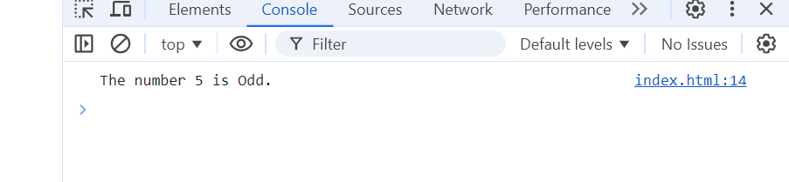

**Q. 17 Write to find the maximum number among 3 numbers using a ternary operator in JS?**

**Ans -**

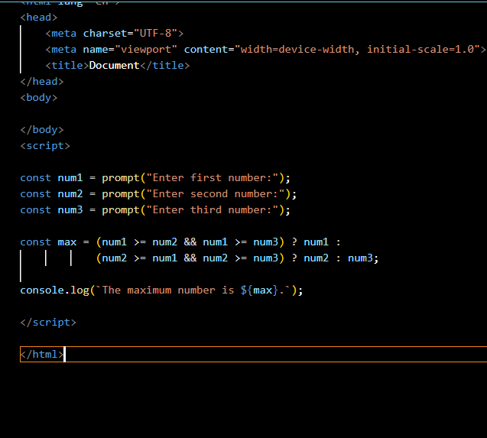

**Output -**

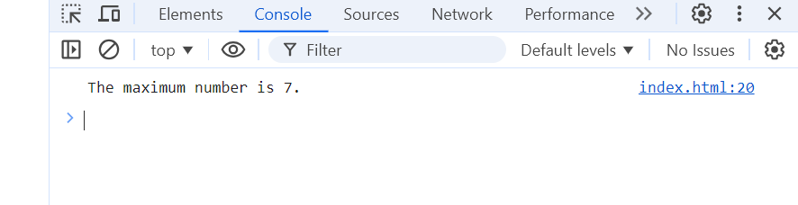

**Q. 18 Write to find the minimum number among 3 numbers using a ternary operator in JS?**

**Ans –**

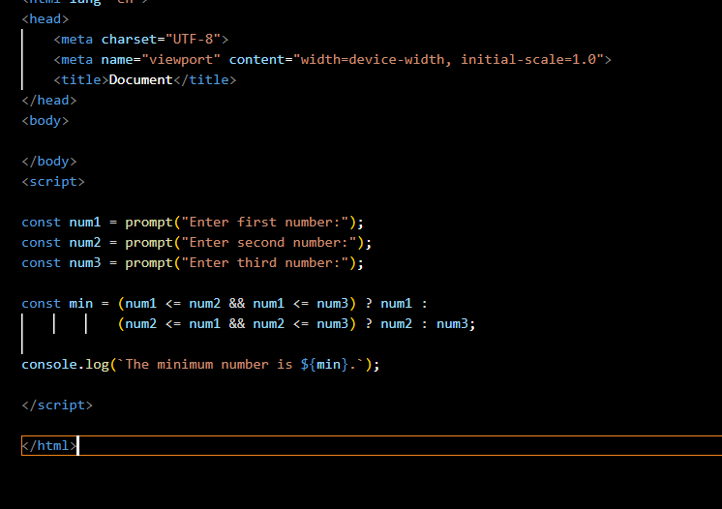

**Output -**

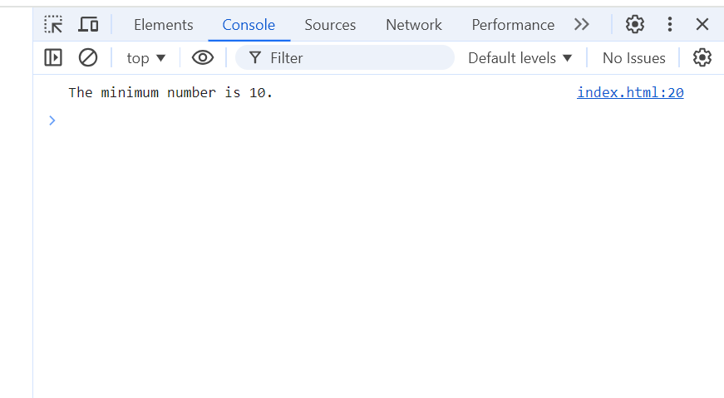

**Q. 19 Write to find the largest of three numbers in JS?**

**Ans –**

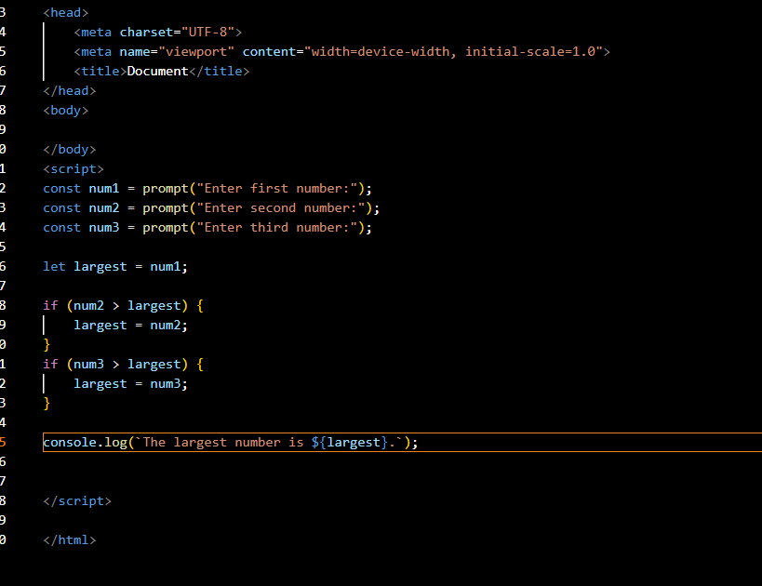

**Output -**

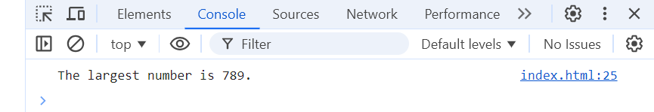

**Q. 20 Write to show**

**i. Monday to Sunday using switch case in JS?**

**ii. Vowel or Consonant using switch case in JS?**

**Ans -** **i - Monday to Sunday using switch case in JS**

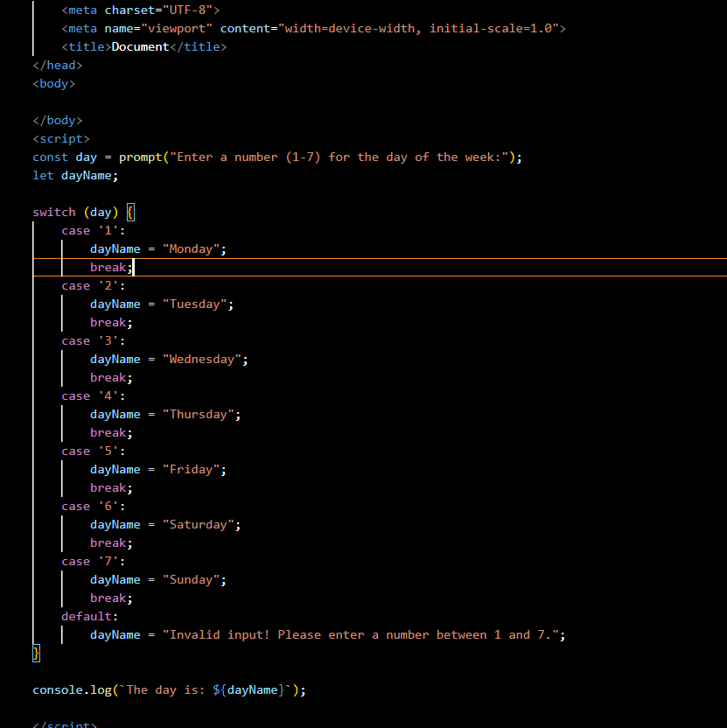

**Output -**

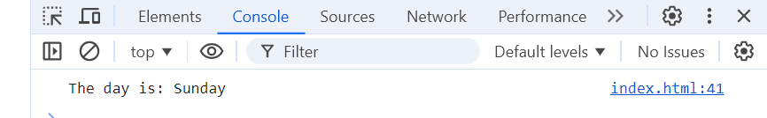

**Ans - ii. Vowel or Consonant using switch case in JS**

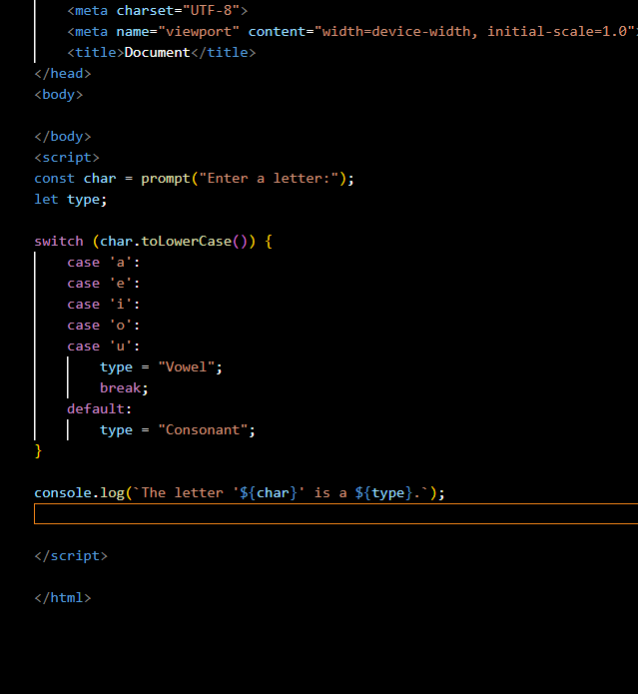  
**Output –**

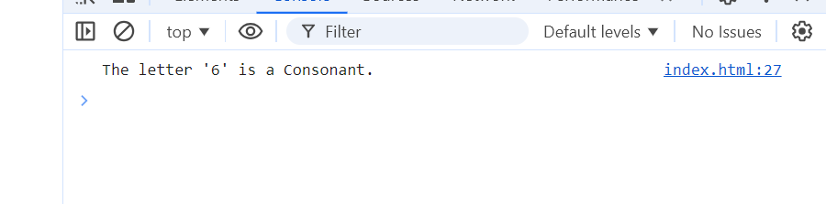

**Q. 21 What are the looping structures in JavaScript? Any one Example?**

**Ans -**

JavaScript has several looping structures, including:

for loop: Used for iterating a block of code a known number of times.

while loop: Executes a block of code as long as a specified condition is true.

do...while loop: Similar to the while loop, but it executes the block of code at least once before checking the condition.

**Example of a for loop:**

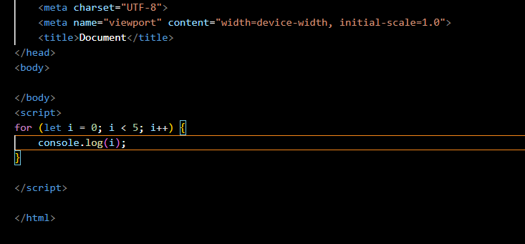

**Output -**

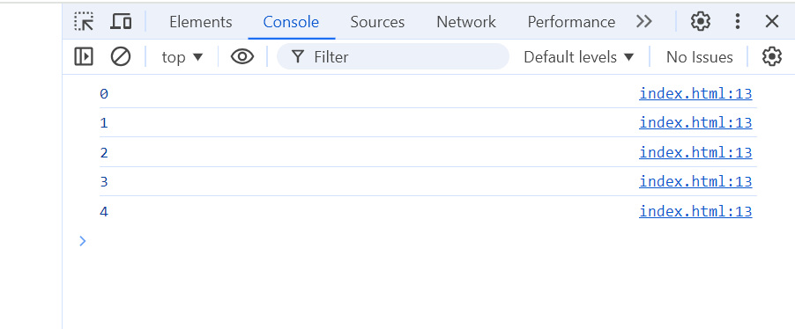

**Q. 22 Write a print 972 to 897 using for loop in JS?**

**Ans -** 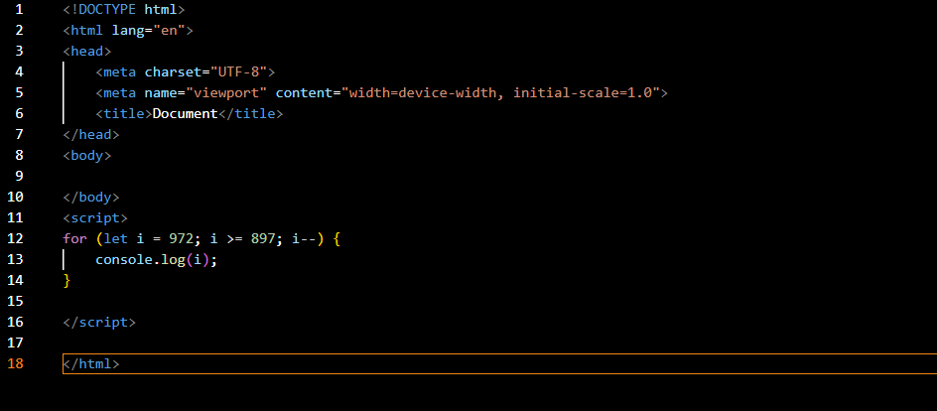

**Q. 23 Write to print factorial of a given number?**

**Ans –**

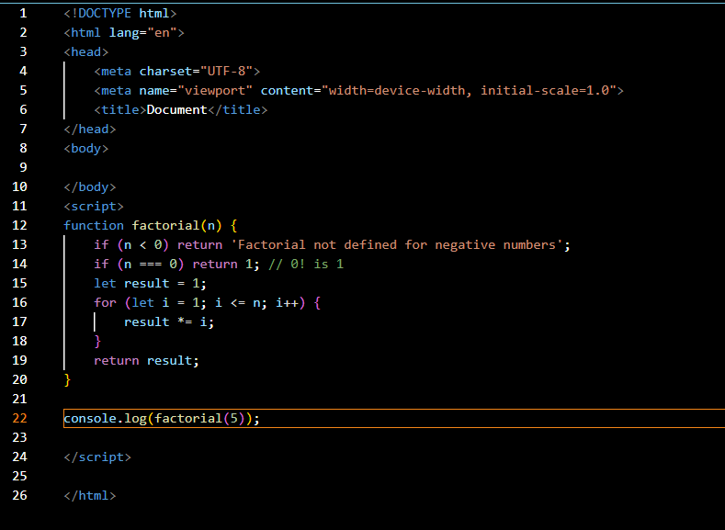

**Output –**

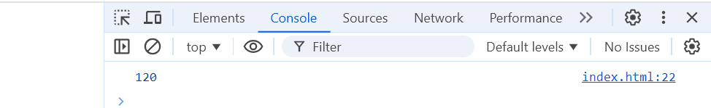

**Q. 24 Write to print Fibonacci series up to given numbers?**

**Ans -** 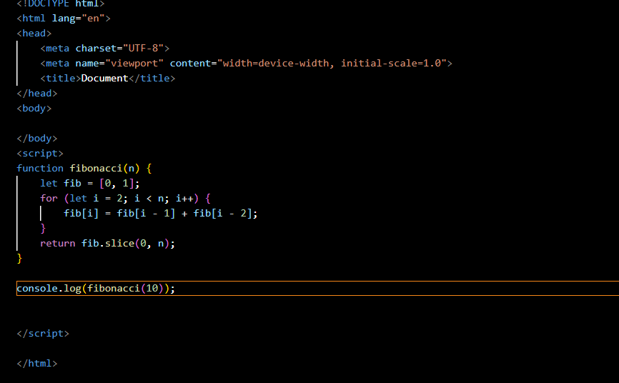

**Output –**

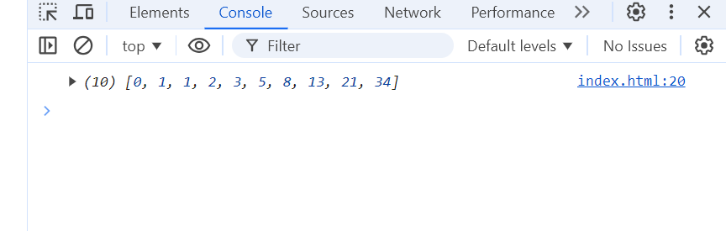

**Q. 25 Write to print number in reverse order e.g.: number = 64728 ---> reverse=82746 in JS?**

**Ans -**

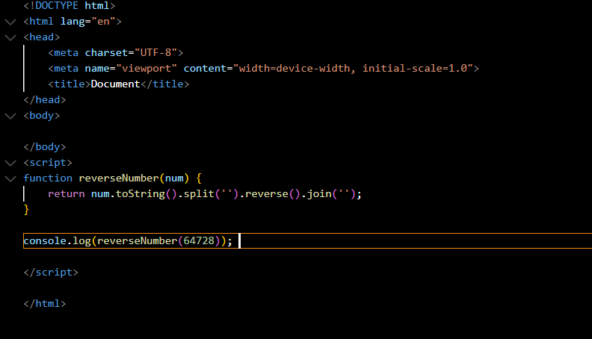

**Output -**

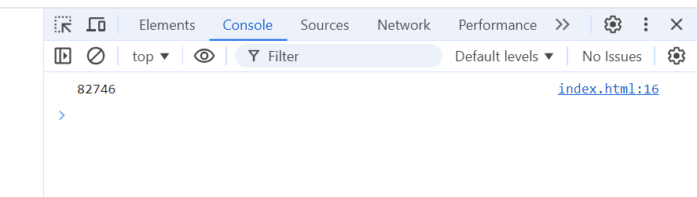

**Q. 26 Write a program to make a summation of a given number (E.g., 1523 Ans: -11) in JS?**

**Ans –**

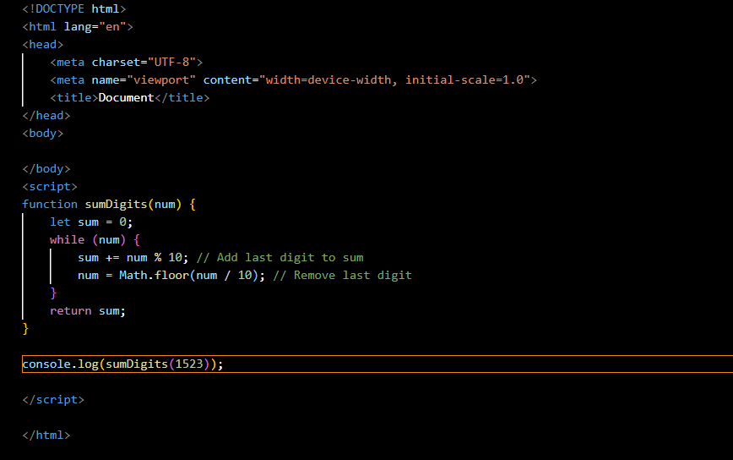

**Output -** 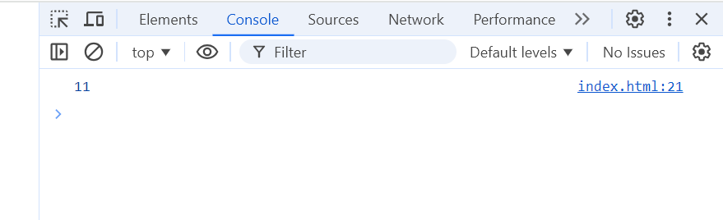

**Q. 27 Write a program to make a summation of first and last Digit (E.g., 1234 Ans: -5) in JS?**

**Ans -** 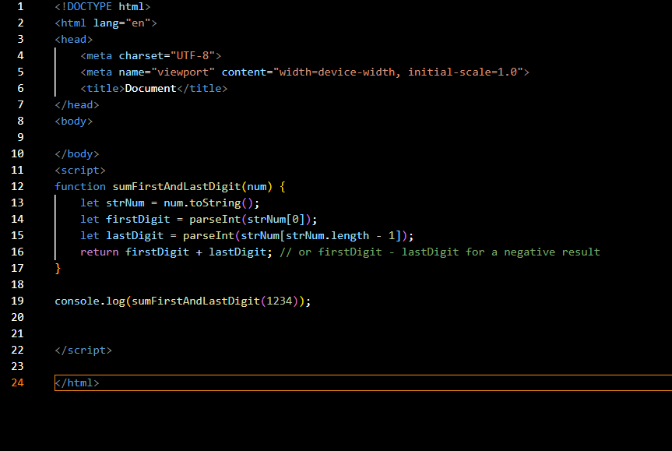

**Output –**

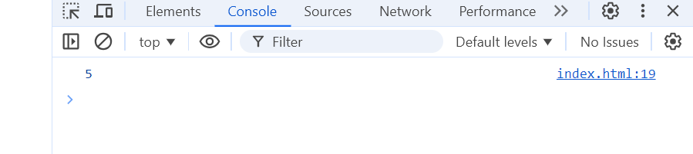

**Q. 28 Use console.log() and escape characters to print the following pattern in JS?**

1 1 1 1 1

2 1 2 4 8

3 1 3 9 27

4 1 4 16 64

5 1 5 25 125

**Ans -** 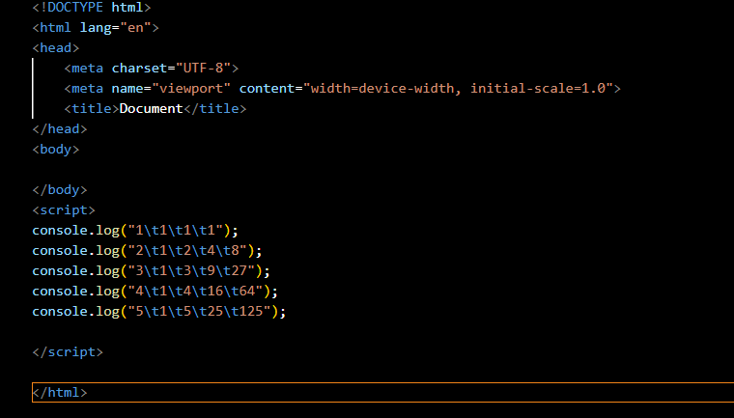

**Output –**

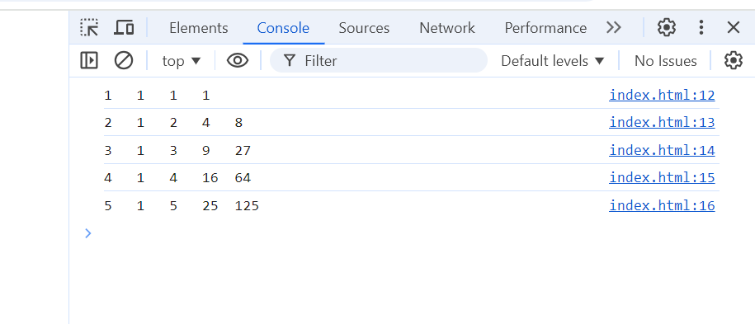

**Q. 29 Use pattern in console.log in JS?**

1) 1

1 0

1 0 1

1 0 1 0

1 0 1 0 1

**Ans -**

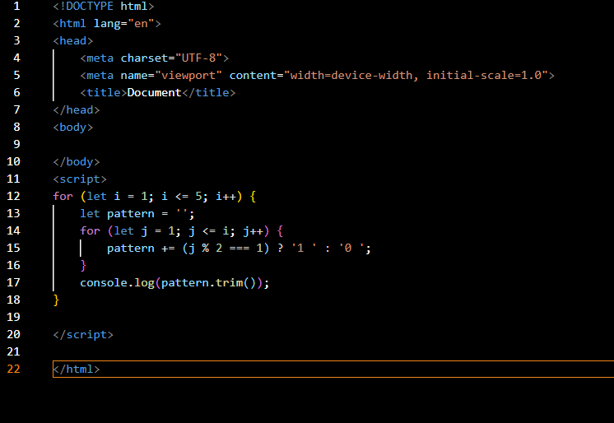

**Output -**

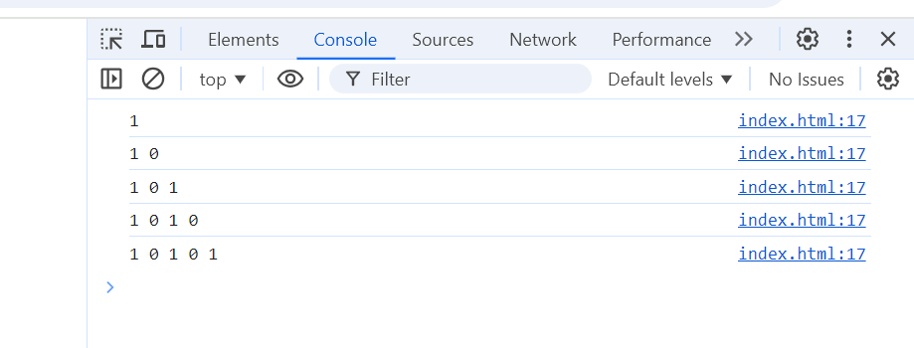

**2. Print the pattern:**

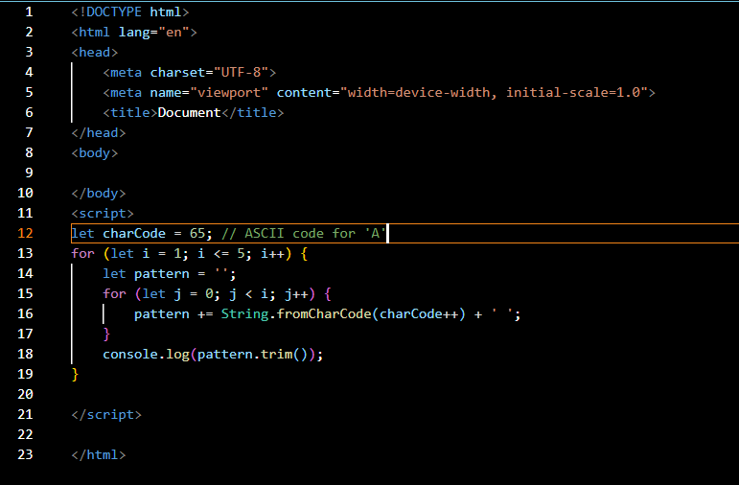

**Output -**

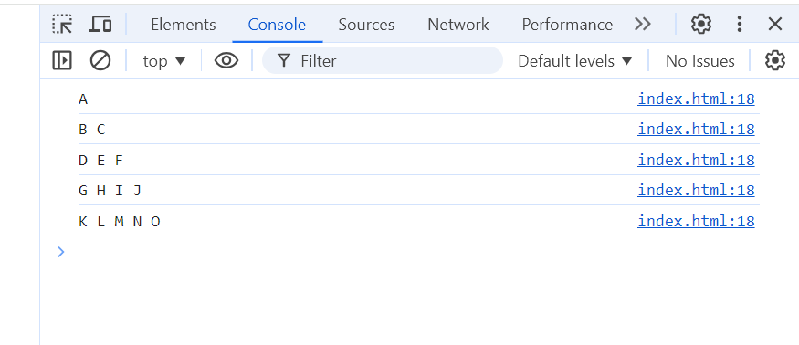

**3- Print the pattern:**

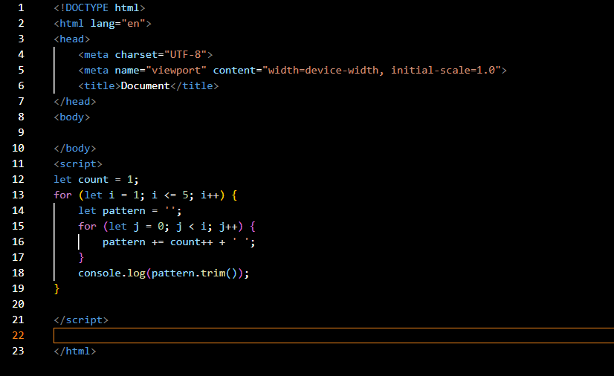

**Output -**

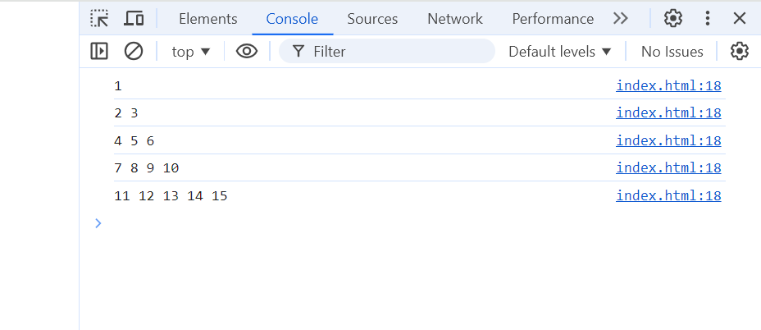

**4 - Print the pattern:**

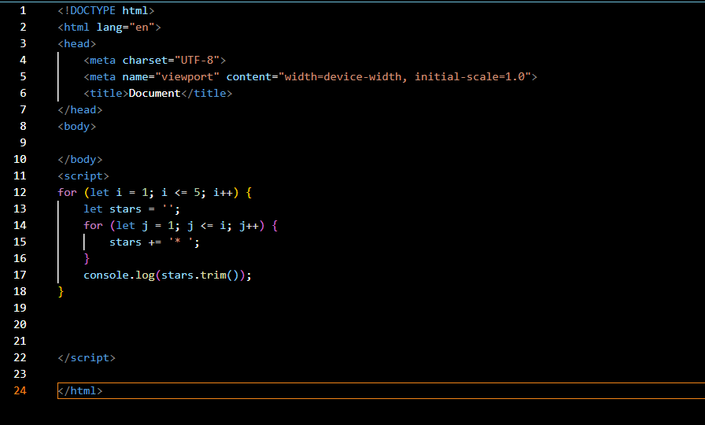

**Output –**

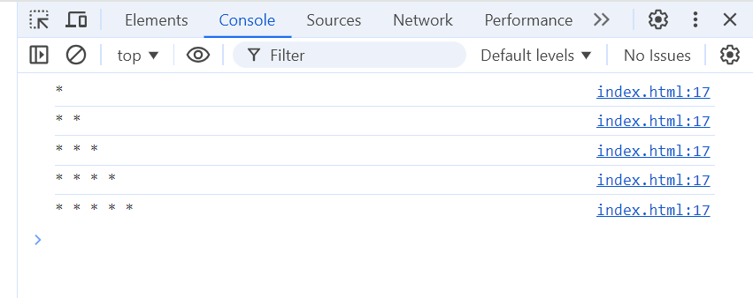

**Q. 30 Accept 3 numbers from user using a while loop and check if each number is a palindrome**

**Ans -** 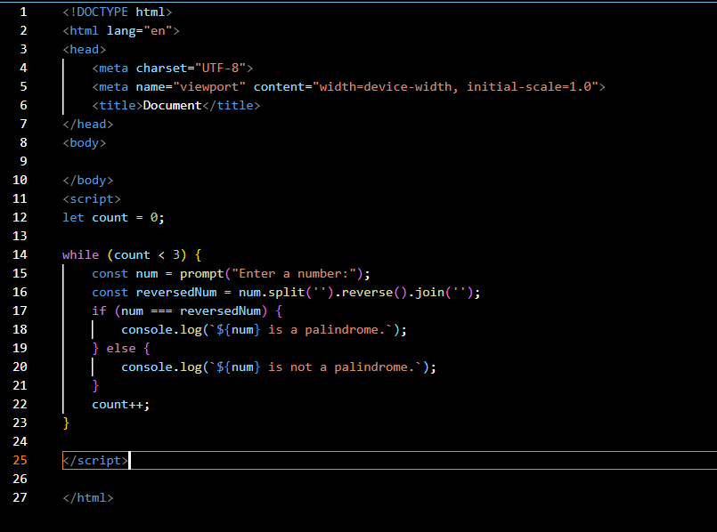

**Output –**

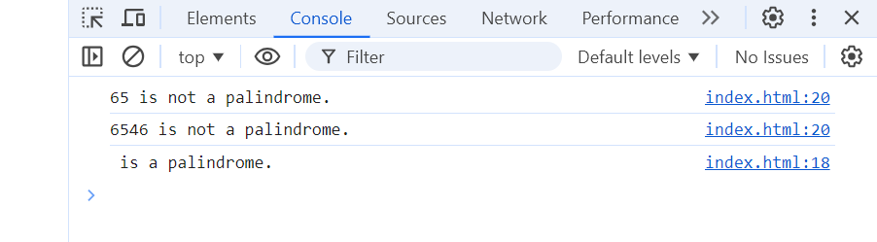

**Q. 31 Write a JavaScript Program to display the current day and time**

**Ans -**

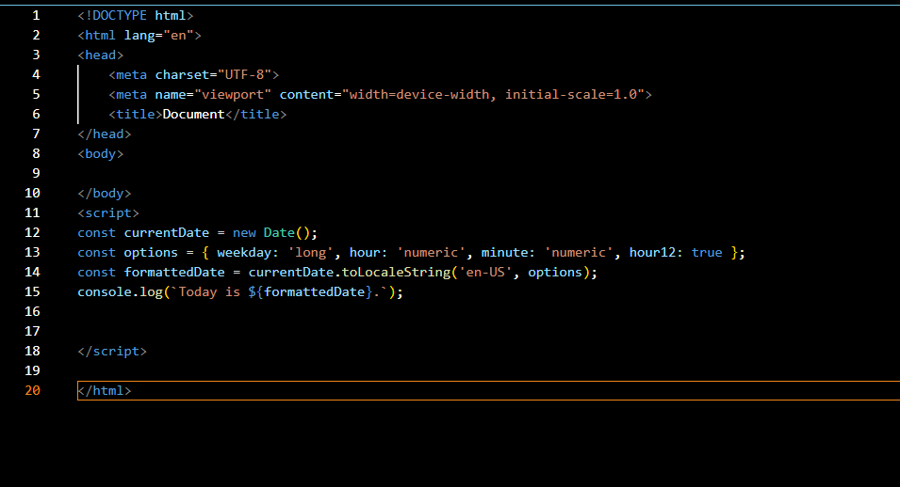

**Output –**

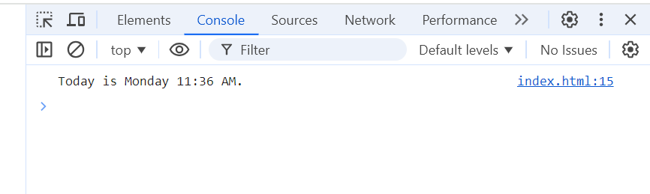

**Q. 32 Write a JavaScript program to get the current date?**

**Ans -**

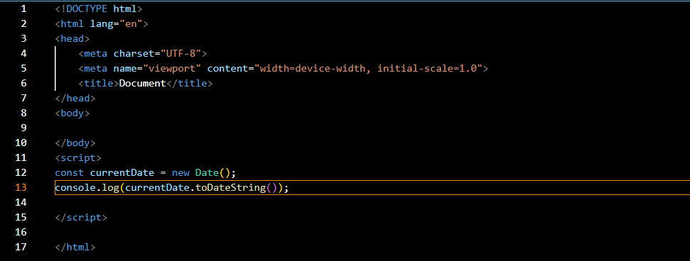

**Output –**

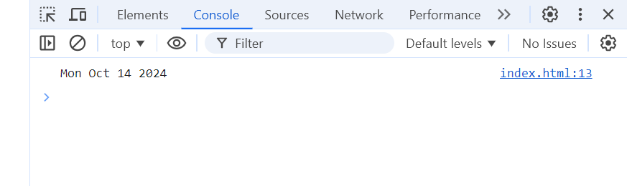

**Q. 33 Write a JavaScript program to compare two objects?**

**Ans -**

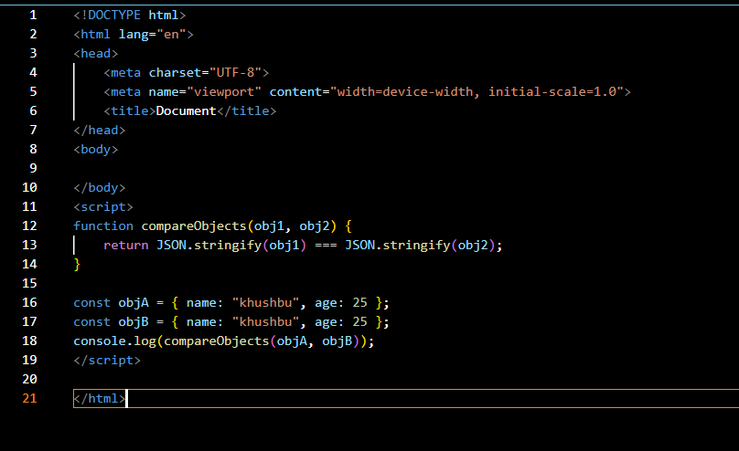

**Output –**

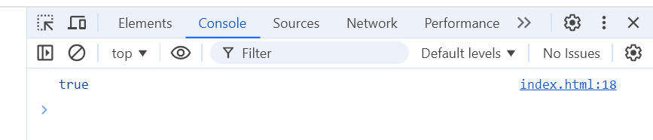

**Q. 34 Write a JavaScript program to convert an array of objects into a CSV string?**

**Ans –**

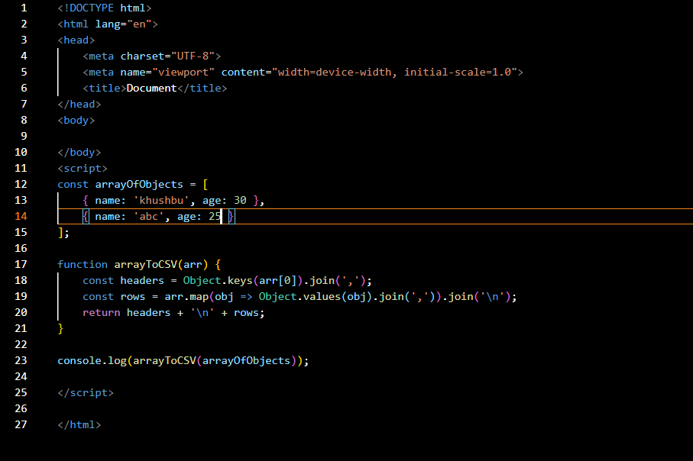

**Output –**

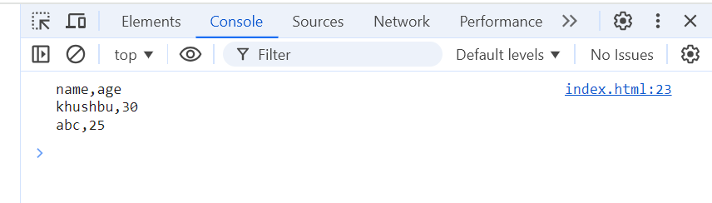

**Q. 35 Write a JavaScript program to capitalize the first letter of a string?**

**Ans -** 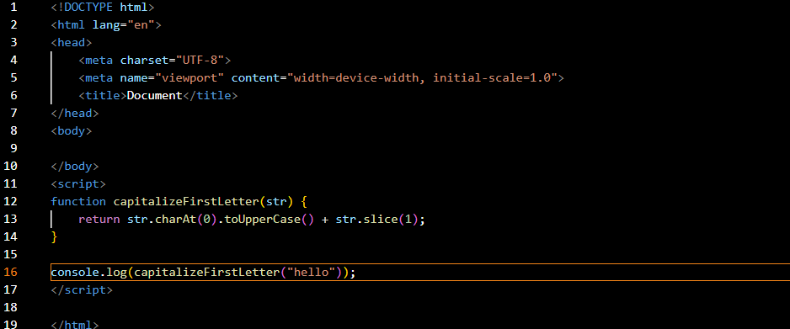

**Output –**

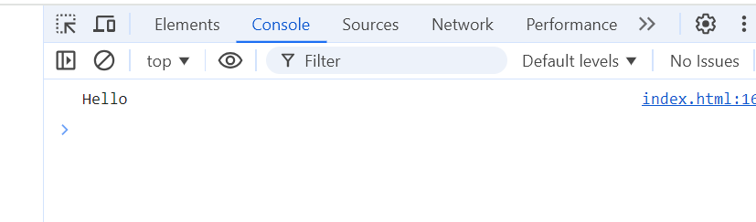

**Q. 45 Write a JavaScript program to determine if a variable is an array?**

**Ans -**

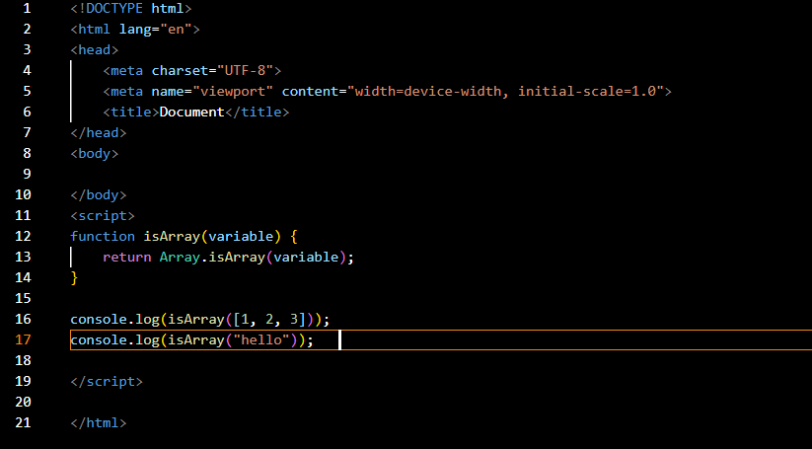

**Output -** 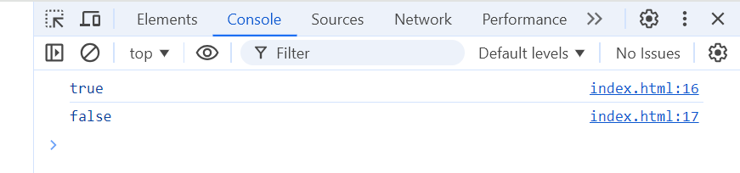

**Q. 46 Write a JavaScript program to clone an array?**

**Ans -**

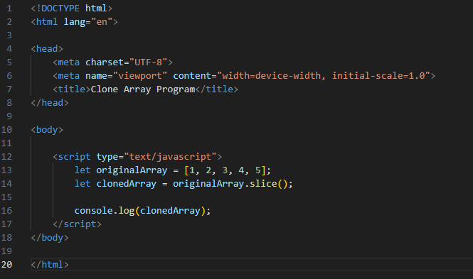

**Output -**

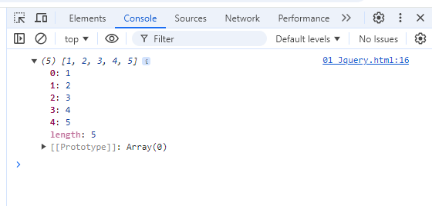

**Q. 47 What is the drawback of declaring methods directly in JavaScript objects?**

**Ans -** The drawback is that methods defined directly within an object do not have access to a parent context when invoked in a different context, which can lead to unexpected behavior, especially with the this keyword.

**Q. 48 Print the length of the string on the browser console using console.log()?**

**Ans -** 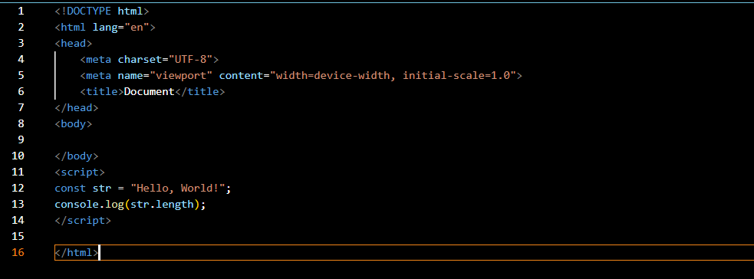

**Output -**

### 

### Q. 49 Change all the string characters to capital letters using toUpperCase() method?

### Ans -

### Output -

### Q. 50 What is the drawback of declaring methods directly in JavaScript objects?

### Ans –

The drawback is that methods defined directly within an object do not have access to a parent context when invoked in a different context, which can lead to unexpected behavior, especially with the this keyword.

Here are the solutions to the additional questions you provided. Each solution includes a JavaScript code snippet and explanations as needed.

**Q. 51 Write a JavaScript program to get the current date in various formats?**

### Ans -

### Output -

### Q. 52 Use indexOf to determine the position of the first occurrence of 'a' in "30 Days Of JavaScript"?

### Ans –

### 

### Output -

### Q. 54 Form Validation in JS?

### Ans –

### Output –

### 

### Q. 55 Form in Email, number, Password, Validation?

### Ans -

### 

### Output -

### 

**Q. 56 Dynamic Form Validation in JS?**

**Ans -** Dynamic form validation in JavaScript is about providing real-time feedback to users as they interact with form fields.

This makes forms more user-friendly and helps prevent submission of invalid data.

### Q. 57 How many types of JS Events? How to use it?

Ans -

1.onchange = An HTML element has been changed

<button onchange ="document.getElementById('demo').innerHTML = Date()">The time is?</button>

2.onclick = The user clicks an HTML element

<button onclick="document.getElementById('demo').innerHTML = Date()">The time is?</button>

3.onmouseover = The user moves the mouse over an HTML element

<button onmouseover ="document.getElementById('demo').innerHTML = Date()">The time is?</button>

4.onmouseout=The user moves the mouse away from an HTML element

<button onmouseout ="document.getElementById('demo').innerHTML = Date()">The time is?</button>

5.onkeydown = The user pushes a keyboard key

<button onkeydown ="document.getElementById('demo').innerHTML = Date()">The time is?</button>

6.onload = The browser has finished loading the page

<button onload ="document.getElementById('demo').innerHTML = Date()">The time is?</button>

### Q. 60 ****What is BOM vs DOM in JS?****

### ****Ans -****

**BOM (Browser Object Model):**

* BOM refers to objects provided by the browser that allow interaction with the browser itself.
* Examples include window, navigator, screen, location, history, and alert().
* It allows JavaScript to manipulate the browser window and other browser functionalities, like navigating, getting browser information, etc.

**DOM (Document Object Model):**

* DOM is a programming interface for web documents. It represents the structure of a webpage as a tree of objects (nodes).
* JavaScript can interact with and manipulate the content, structure, and style of a webpage using the DOM.
* Examples include document.getElementById(), document.querySelector(), and element.innerHTML.

### Q. 61 ****Array vs Object differences in JS?****

### ****Ans-****

### Arrays

### Arrays are ordered collections of values, which can be accessed by their index

### They are created using square brackets [] or the Array constructor.

### Syntax:

### let arr = [1, 2, 3, 4];

### let arr2 = new Array(1, 2, 3, 4);

### Each element in an array has a numerical index starting from 0.

### Arrays have a length property that dynamically updates as elements are added or removed.

### Objects

### Objects are collections of key-value pairs, where keys (also called properties) are strings or symbols, and values can be of any data type.

### They are created using curly braces {} or the Object constructor.

### Syntax:

### let obj = { name: "Alice", age: 25 };

### let obj2 = new Object();

### obj2.name = "Alice";

### obj2.age = 25;

### Each value is accessed using a unique key.

### Properties can be added, modified, or deleted at runtime.

### Q. 62 **Split the string into an array using** split() **method**

### ****Ans -****

The split() method divides a string into an array of substrings, based on a specified separator.

### 

**Output –**

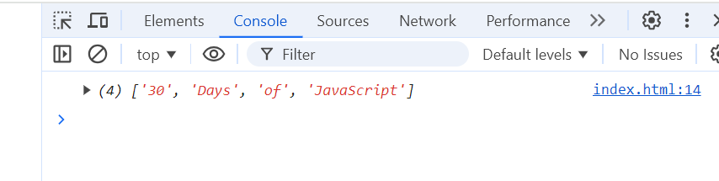

### Q. 63 ****Check if the string contains a word "Script" using**** includes() ****method****

### ****Ans -****

The includes() method checks whether a string contains a specified substring, returning true or false. 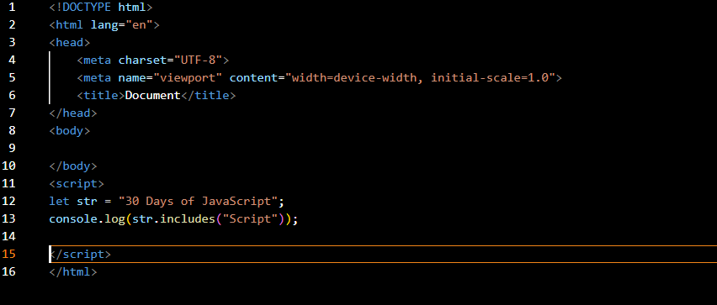

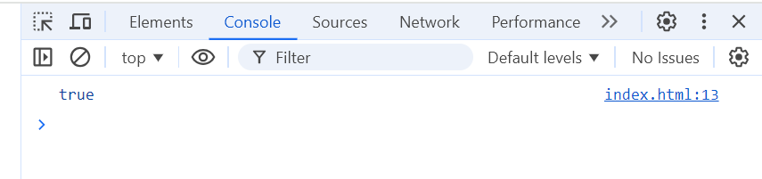

### Q. 64 ****Change all the string characters to lowercase letters using**** toLowerCase() ****method****

### ****Ans -****

The toLowerCase() method converts all the characters in a string to lowercase.

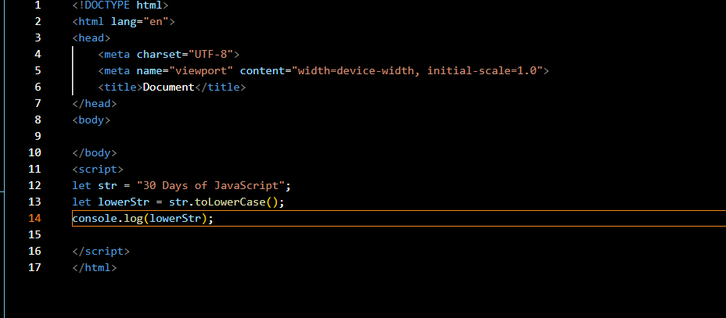

**Output -**

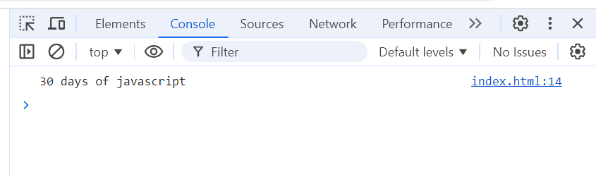

### Q. 65 ****What is the character at index 15 in "30 Days of JavaScript" string? Use**** charAt() ****method****

### ****Ans -****

The charAt() method returns the character at a specified index in a string.

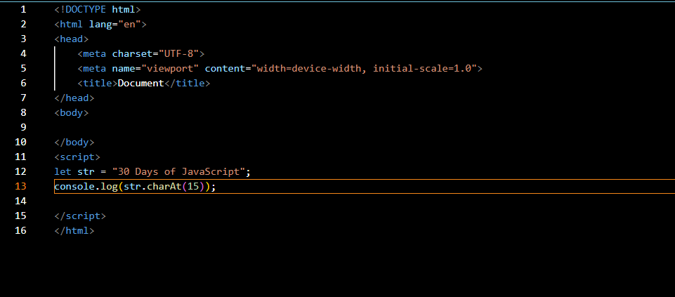

**Output -**

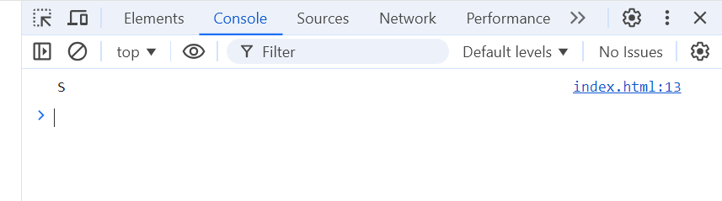

**Q. 66 Copy one string to another string in JS**

**Ans -**

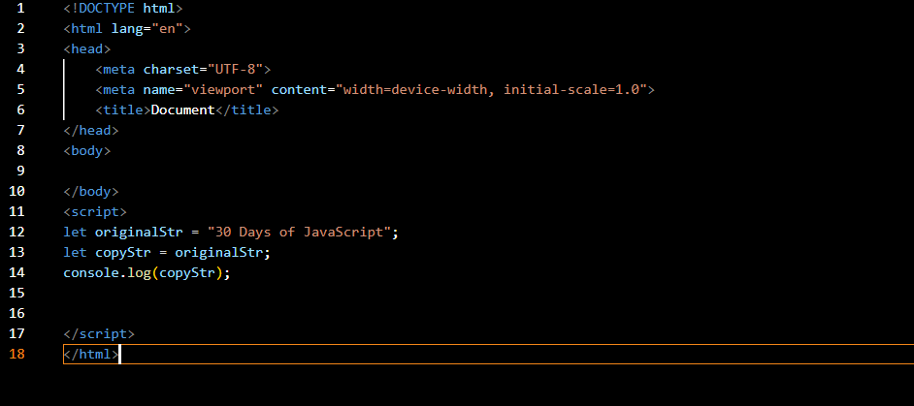

**Output -**

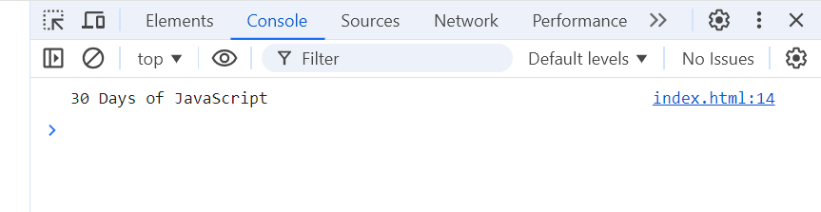

**Create basic math operation in JS** 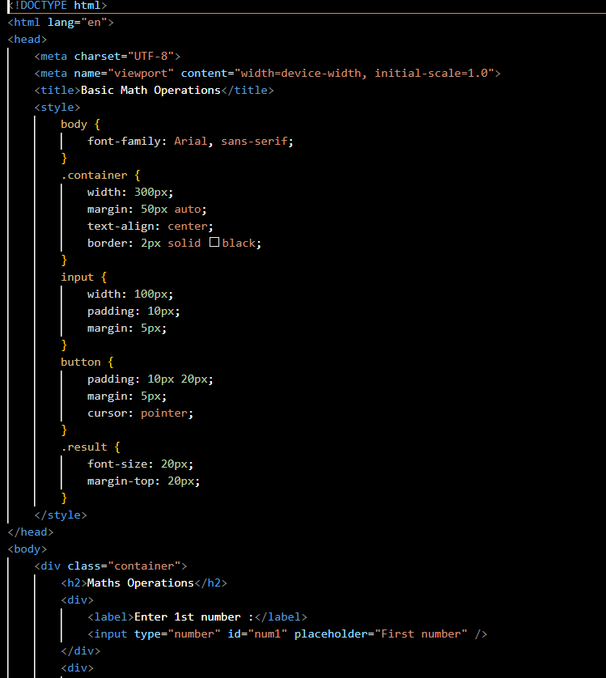

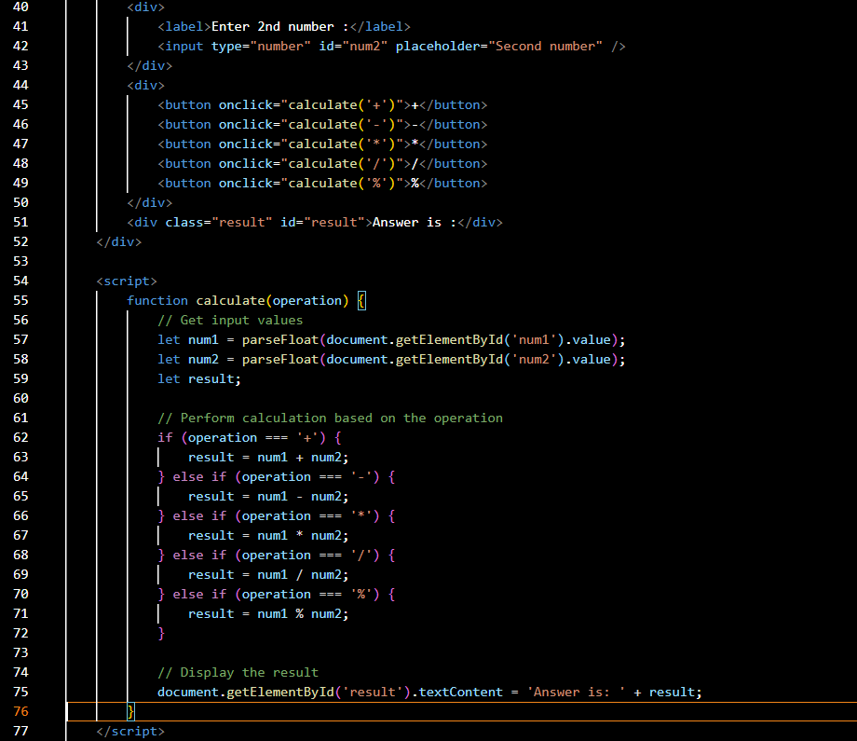

**Output -**

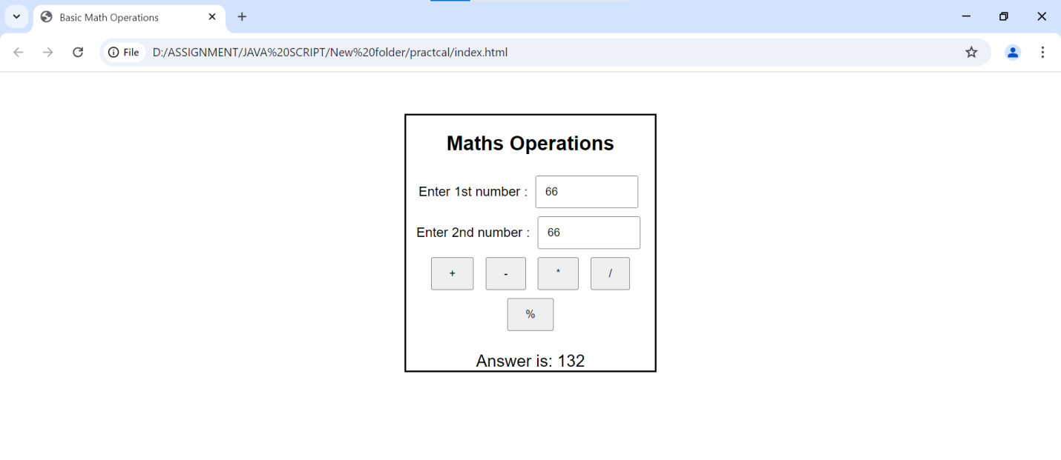

**Create Result**

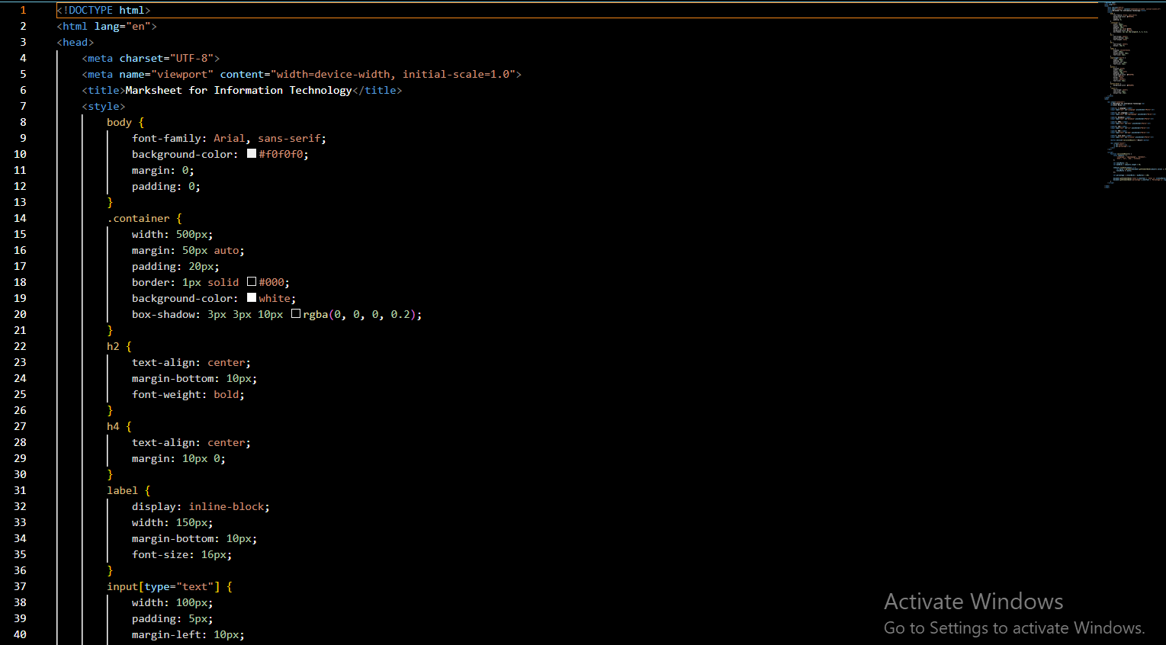

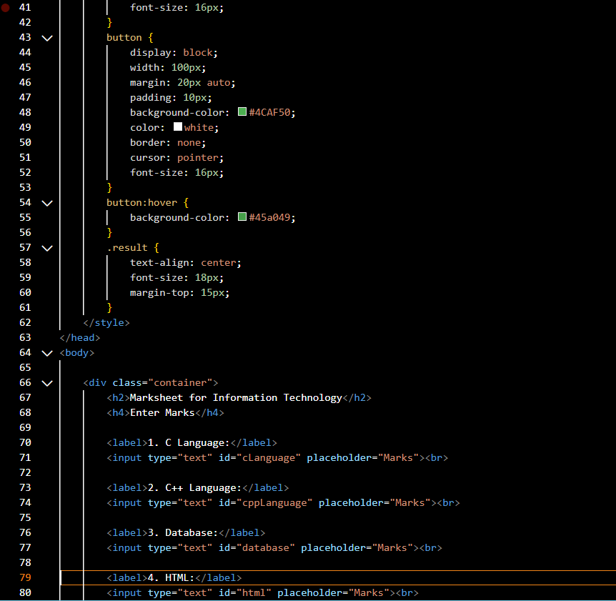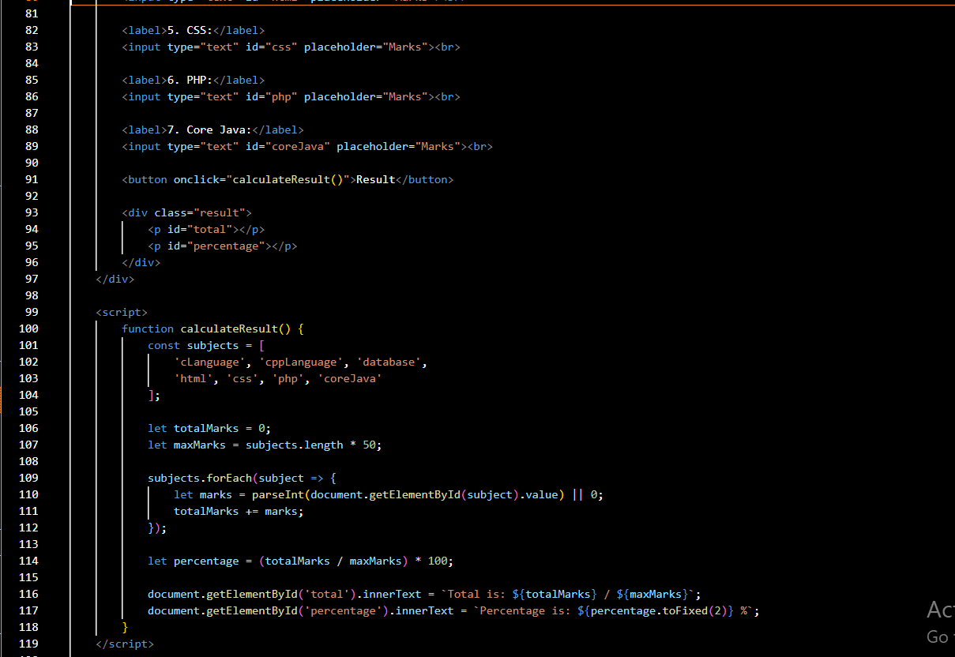

**Output –**

